Experiment 9

AIM:

Write a program to string operations using operator overloading:

- =, string copy
- ==, >, <, comparision
- +, concatenation

Theory:

C++ allows you to specify more than one definition for an operator in the same scope, which is called operator overloading. An overloaded declaration is a declaration that is declared with the same name as a previously declared declaration in the same scope, except that both declarations have different arguments and obviously different definition (implementation). You can redefine or overload most of the built-in operators available in C++. Thus, a programmer can use operators with user-defined types as well. Overloaded operators are functions with special names: the keyword "operator" followed by the symbol for the operator being defined. Like any other function, an overloaded operator has a return type and a parameter list.

Code:

#include <iostream>


#include < cstring >
using namespace std;
class String {
char * s;

int len;
int cmp(const String & a,
const String & b) {
int i = 0, j = 0;
while (i < a.len && j < b.len) {
if (a.s[i] < b.s[j])
return -1;
else if (a.s[i] > b.s[j])
return 1;
i++;
j++;

}
if (a.len < b.len)
return -1;
else if (a.len > b.len)
return 1;
else

return 0;

}
public: String() {
s = '\0';
len = 0;

}
String(char * p) {
len = strlen(p);
s = new char[len + 1];
strcpy(s, p);
}
void operator = (const String & a) { delete s;

len = a.len;
s = new char[len + 1];
s = strcpy(s, a.s);
}

bool operator < (const String & a) { return cmp( * this, a) == -1;
}
bool operator > (const String & a) {

return cmp( * this, a) == 1;
}
bool operator == (const String & a) { return cmp( * this, a) == 0;

}

String operator + (const String & b) { char * n = new char[len + b.len + 1]; strcpy(n, s);
strcat(n, b.s);
String ans = String(n);
delete[] n;

return ans;
}
friend ostream & operator << (ostream & , String & ); friend istream & operator >> (istream & , String & );

};

ostream & operator << (ostream & op, String & a) { op << a.s;
return op;
}

istream & operator >> (istream & op, String & a) { char temp[100];

cin >> temp;
a = String(temp);
return op;
}
int main() {
String a, b, c;
cin >> a >> b;

cout << a << " == " << b << " : " << (a == b) << endl;

cout << a << " < " << b << " : " << (a < b) << endl; cout << a << " > " << b << " : " << (a > b) << endl; c = a + b;

cout << a << " + " << b << " : " << c << endl; return 0;

}
Output:
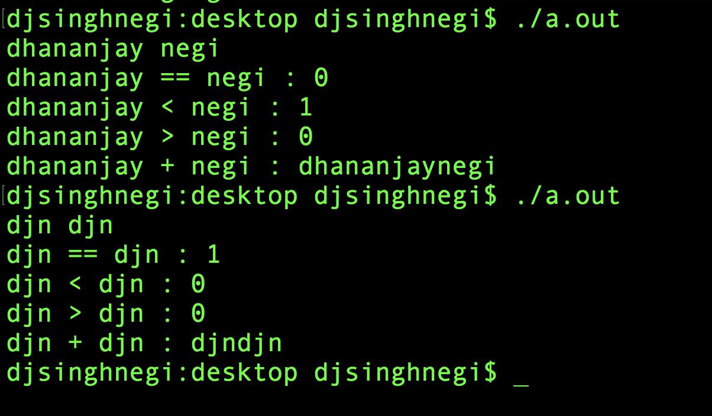

Discussion:

The operators +,=,==,< and > have been overloaded for string operations.

